My title for Submission to Virtual Geoscience Conference 2025

Author1^{1*}, Author2²
¹ My Laboratory or company or university address, author1@cerege.fr
² My Laboratory or company or university address

Key words: keyword1,…

This document presents the mandatory instructions to authors for the preparation of submissions to VGC 2025. Abstracts should be between 350-500 words in length and may include 1-2 figures showcasing the contribution of the proposed research. The abstract should be no longer than two letter size pages. Submissions may be made using Microsoft Word. Consistent formatting between submissions allows the final abstract volume to be published in a uniform way.
Font: use Times New Roman (16 point, bold for main title; 10 point for main text; italic for affiliations and key words).
Include all authors and affiliations as shown above. For each institution, please indicate address and country. Corresponding author should be indicated with superscript*, and their email address supplied. Separate authors’ names with a comma except between the last ones where “&” should be used. Please choose three to six key words representing the themes of your submission.
Figures: 1 or 2 figures may be included to illustrate your contribution. For highest impact, figures should be as self-explanatory as possible when combined with the abstract body and a short caption (Fig. 1; Fig. 2). Please compress your images, where possible, to reduce the final document file size.

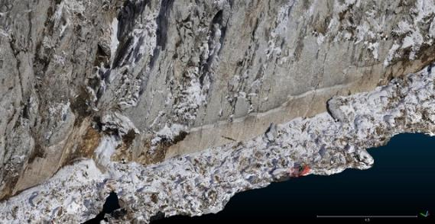
Figure 1: Add a figure with simple caption to help showcase the impact of your research

References may be included if necessary, and cited in the text (Jaboyedoff, 2012). If there are two authors please separate the names using “&”, as in (Humair & Matasci, 2013). In the case of more than two authors, indicate only the first author’s name followed by et al., as in (Sima et al., 2013). Indicate author names using small caps. References, where used, should be listed in alphabetical order at the end of the paper following the format presented below.

Acknowledgements: may be optionally included to acknowledge funding bodies, industry support or other contributions.

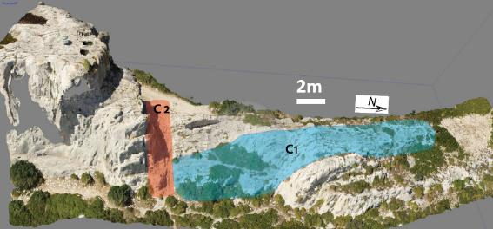
Figure 2. Add a figure with simple caption to help showcase the impact of your research.

References
Denk, M., Gläßer, C., Kurz, T.H., Buckley, S.J., & Drissen, P., 2015. Mapping of iron and steelwork by-products using close range hyperspectral imaging: A case study in Thuringia, Germany. European Journal of Remote Sensing, 48: 489-509.
Jaboyedoff, M., Oppikoffer, T., Abellán, A., Derron, M.-H., Loye, A., Metzger, R. & Pedrazzini, A., 2012. Use of LIDAR in landslide investigations: a review. Natural Hazards, 61: 5-28.
Sima, A.A., Buckley, S.J. & Viola, I., 2012. An interactive tool for analysis and optimization of texture parameters in photorealistic virtual 3D models. International Annals of the Photogrammetry, Remote Sensing and Spatial Information Sciences, I(2): 165-170.

